|  |  |
| --- | --- |
| **Semester Project** | **Database Design – Fall 2020** |
| Due 12/01/2020  **Jonathan Schroeter**  **JAS170005** | “High Quality PNGs of Diagrams and Physical Schema” folder holds PNGs of Diagrams and the physical schema  “SQL Tables_inserts_queries” folder holds the SQL tables, insert, and query scripts, Also holds the dummy data list and a better view of SQL tables |

There is an XYZ Company, which purchases some parts from vendors to produce some products. It has several departments, marketing sites, and parts supply vendors in the company.

**Problem Description**

The problem for this project was to create a database for XYZ Company so they could store their own employee/department/site information, but to also store extended information that the company will use. It needs to store information about vendors who the company works with for part purchases, and customers that the company is selling their products to. The database needs to hold all this information, and the additional requirements given in the project requirements.

**Requirements and Design Assumptions/Decisions:**

1. For each department, department id and department name will be recorded.

-Assumptions and Design Decisions:

-Each department will have a manager, but only one manager.

-Department names are not unique, their might be two different “marketing” departments, but their ids will be different

-The department id is between 100 and 999

2) People in the company can be divided into three types -- employees, customers, and potential employees. Each person can belong to more than one type. Each person in the company has the following attributes: Personal_ID, Name (Last Name, First Name), Age (below 65), Gender, Address (address line 1, address line 2, city, state, zipcode), and Phone number (one individual may have more than one phone number). For customers, his/her preferred salesmen were recorded in the system. For employees, Rank and Title (e.g. CEO, Principle, Partner, etc.) will be recorded for them.

-Assumptions and Design Decisions:

-Everyone will be included in the person class, and the specialization/generalization will be used to have total overlapping where someone could be an employee, customer, and a potential employee, or vice versa.

-Email is not unique. People can share emails (IE the customer support team has one email account) and each person will only have 1 each account for work

-Phone number is not unique either, but since people could have multiple phone numbers, it will be made into its own table

-Limit on the age of a person, to be in the database they must between 16 and 65

-The customers preferred salesman must be an employee

3) Each employee of the company must have only one direct supervisor, while each supervisor can have several supervisees. One employee can work for one or more departments at different time. But at one time, one employee can only work for one department. The system needs to record start time and end time for each shift among different department for one employee.

-Assumptions and Design Decisions:

-An employee does not have to have a supervisor, but if it does it can only have 1

-I took the requirement that says, “One employee can work for one or more departments at different time. But at one time, one employee can only work for one department.” As that an employee can have different shifts within the company, but each shift is within only one department. John Smith might work for marketing one day, but the next day he might work in the sales department. Therefore, an employee is not specifically assigned to a department, but only assigned during their shift.

-Each department_id will be between 100 and 999

4) Each job position’s information is recorded to hire new people. It contains the Job ID, job description, and posted date in the system.

-Assumptions and Design Decisions:

-The job_id will be a number between 1 and 9999999

-The posted_date will be in timestamp format so more data can be gotten about exactly when the job was posted.

-Each department will post these jobs

5) The job positions are posted by the departments. Both existing employees and potential employees can apply each job post by any department. The company will select some candidates from the applications and make interviews.

-Assumptions and Design Decisions:

-Anyone in the person table can apply for the positions since the positions are open to everyone.

-After they apply, all people will be in the potential employee table so they can be picked for interviews.

-For the company to make selections for interviews, they must be in the potential employee table.

6) For each job position, several interviews will be made to select a suitable person.

-Assumptions and Design Decisions:

-A potential employee can interview for multiple positions.

7) For each interview, candidates (interviewees), interviewers, job position and interview time are recorded. After each round interview, the interviewers give a grade to it ranging from 0 to 100. The grade over 60 represents that the interviewee pass the interview. One person is selected when her/his average grade is over 70 and she/he passes at least 5 rounds of interviews.

-Assumptions and Design Decisions:

-An employee must be the interview

-Only one interview per round

-There can be many different interviews for one job position.

-The primary keys are (Canidate_id, Job_ID, Round_number) these are the only items needed to create a unique match

-Interviews can be at the same time

8) For each product in the company, the system needs to record Product ID, Product Type, Size, List Price, Weight, and Style.

-Assumptions and Design Decisions:

-The primary key will be the Product_id

-Product names could be the same, but their id will be different. There could be two “wheels” but one wheel could have a different size and weight, therefore the name is not unique.

- List_price between 1 and 99999

- Weight between 1 and 99999

- Product_Size between 1 and 99999

9) There are many marketing sites for the company. For each site, Site ID, Site Name, and Site Location are recorded.

-Assumptions and Design Decisions:

-The primary key will be the Site_ID

-The site_name is not unique. There could be two different sites with the same name, therefore name is not unique.

-A full address for the site is not put, only the city and state where it resides.

-Site_ID between 1 and 99999

10) There are several people working for each site, and meanwhile, one person can work on different sites. It is able to track the details of each sale history --- salesmen, customers, product, sale time, and sites.

-Assumptions and Design Decisions:

-One person can be a worker for different sites.

-Each site can have an unlimited number of workers.

-So, the unique match for Site_workers would be Site_ID, Personal_ID

-Employees can only work at the sites

11) Part purchase is also a vital activity in the company. The system needs to record each vendor’s Vendor ID, Name, Address, Account Number, Credit Rating, and Purchasing Web Service URL.

-Assumptions and Design Decisions:

-When buying parts, the company will pick the cheapest price for each part.

-Part_id between 1 and 99999

-Price between 1 and 99999

-Account_number between 1 and 99999

-Credit_rating between 1 and 99999

-Account number is not unique, two different vendors could share the same account number if they have the same parent company.

-Also, the vendor name is not unique, could be two vendors with the same name.

-Vendor_ID is the only unique aspect of the vendors

12) One vendor may supply many types of parts. The price of the same part type may vary from different vendors but the price of one part type of one vendor will keep same. It can track which part types used in each product and the number of each type of part used for the product.

-Assumptions and Design Decisions:

-Many vendors can offer a different price for one part, but when the company decides to buy parts, they will buy from the vendor who is selling that part the cheapest.

-To get the cost per product, it would be the Min(price)*part_amount

-Price between 1 and 99999 (no part is free)

13) In addition, the system maintains the information of each employee’s monthly salary which includes transaction number, pay_date, and amount (Note: transaction number could be same among different employees. However, for each employee, the transaction number is unique).

-Assumptions and Design Decisions:

-PRIMARY KEYS are (Personal_ID, Transaction_number) since two different employees can have transaction 1 for themselves

-Transaction_number between 1 and 999999

- Amount between 1 and 999999999

**Project Questions**

· Can you think 5 more rules (other than the one explicitly described above) that are likely to be used in a company.

-Email is needed for each person (this only mentioned in the queries, therefore this should be a rule)

-The company will use the cheapest costing parts for the products

-Only employees can be interviewers

-Employees must be 16 or over to work for the company (to meet Texas state law)

-Phone numbers must be the correct form for US

· Is the ability to model super-class/subclass relationships likely to be important in such environment? Why or why not?

The ability to model super-class/subclass relationships is important because of the Person-Employee-Customers-Potential_Employee tables. It can get rid of duplicate data and reduce space in the environment. We don’t have to store the names in addresses for each person inside Employee or customer, we can store all that stuff within Person and make Employee and Customer subclasses and have them relate to person. Therefore, this would make it very important to have.

· Justify using a Relational DBMS like Oracle for this project.

A DBMS is a good system for storing data and having it relate to other data through aspects of a DBMS like foreign keys/constraints. It can store large amounts of data and allow for this data to be manipulated and retrieved via queries or the such. Oracle allows us to easily take the written requirements and translate into DBMS tables, which can allow non-technical people to write requirements for technical projects.

**Project Exercises**

**I.** Draw an EER to accurately represent this set of requirements. This will be your Conceptual Design. Clearly specify any assumption that you are making. You can use any tools (software) to draw the EER. You don’t need describe the value constraints of the attributions in the EER diagram. (25%)

(See EER_DIAGRAM.

Many of the more major assumptions were made up above, but here are the ones only explain EER choice

-Total overlapping between Person-Employee-Potential_employee, and customer since it can be any or all of them.

-Supervision is a relation from employee to employee for a supervisor for employees

-Employees do not have to work at sites, some may be completely remote

-Someone may apply for a job, but it does not mean they have to get an interview

-Anyone can apply for a job, and once they do they immediately become a potential employee

**II.** Use a relational DBMS to implement the database. Perform the following steps. (20%)

a) Convert your Conceptual model to a Logical model that can be implemented in a relational DBMS like Oracle. During this process you replace M-N relationships and multi-valued attributes with constructs that can be implemented in the relational DBMS. Draw EER for the logical model after your modifications Feel free to change your conceptual model (first delivery) if needed.

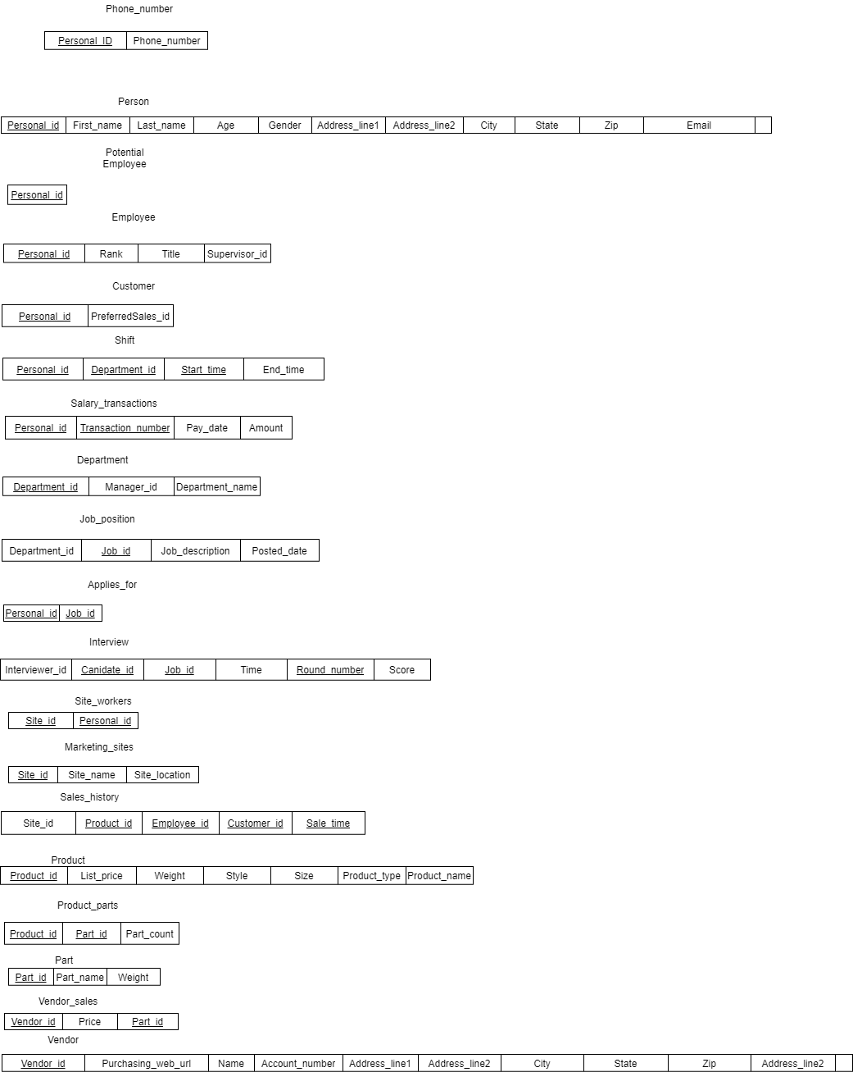

b) Convert the EER to a database design. Document your design in Database Schema format like the one we discussed in the class.

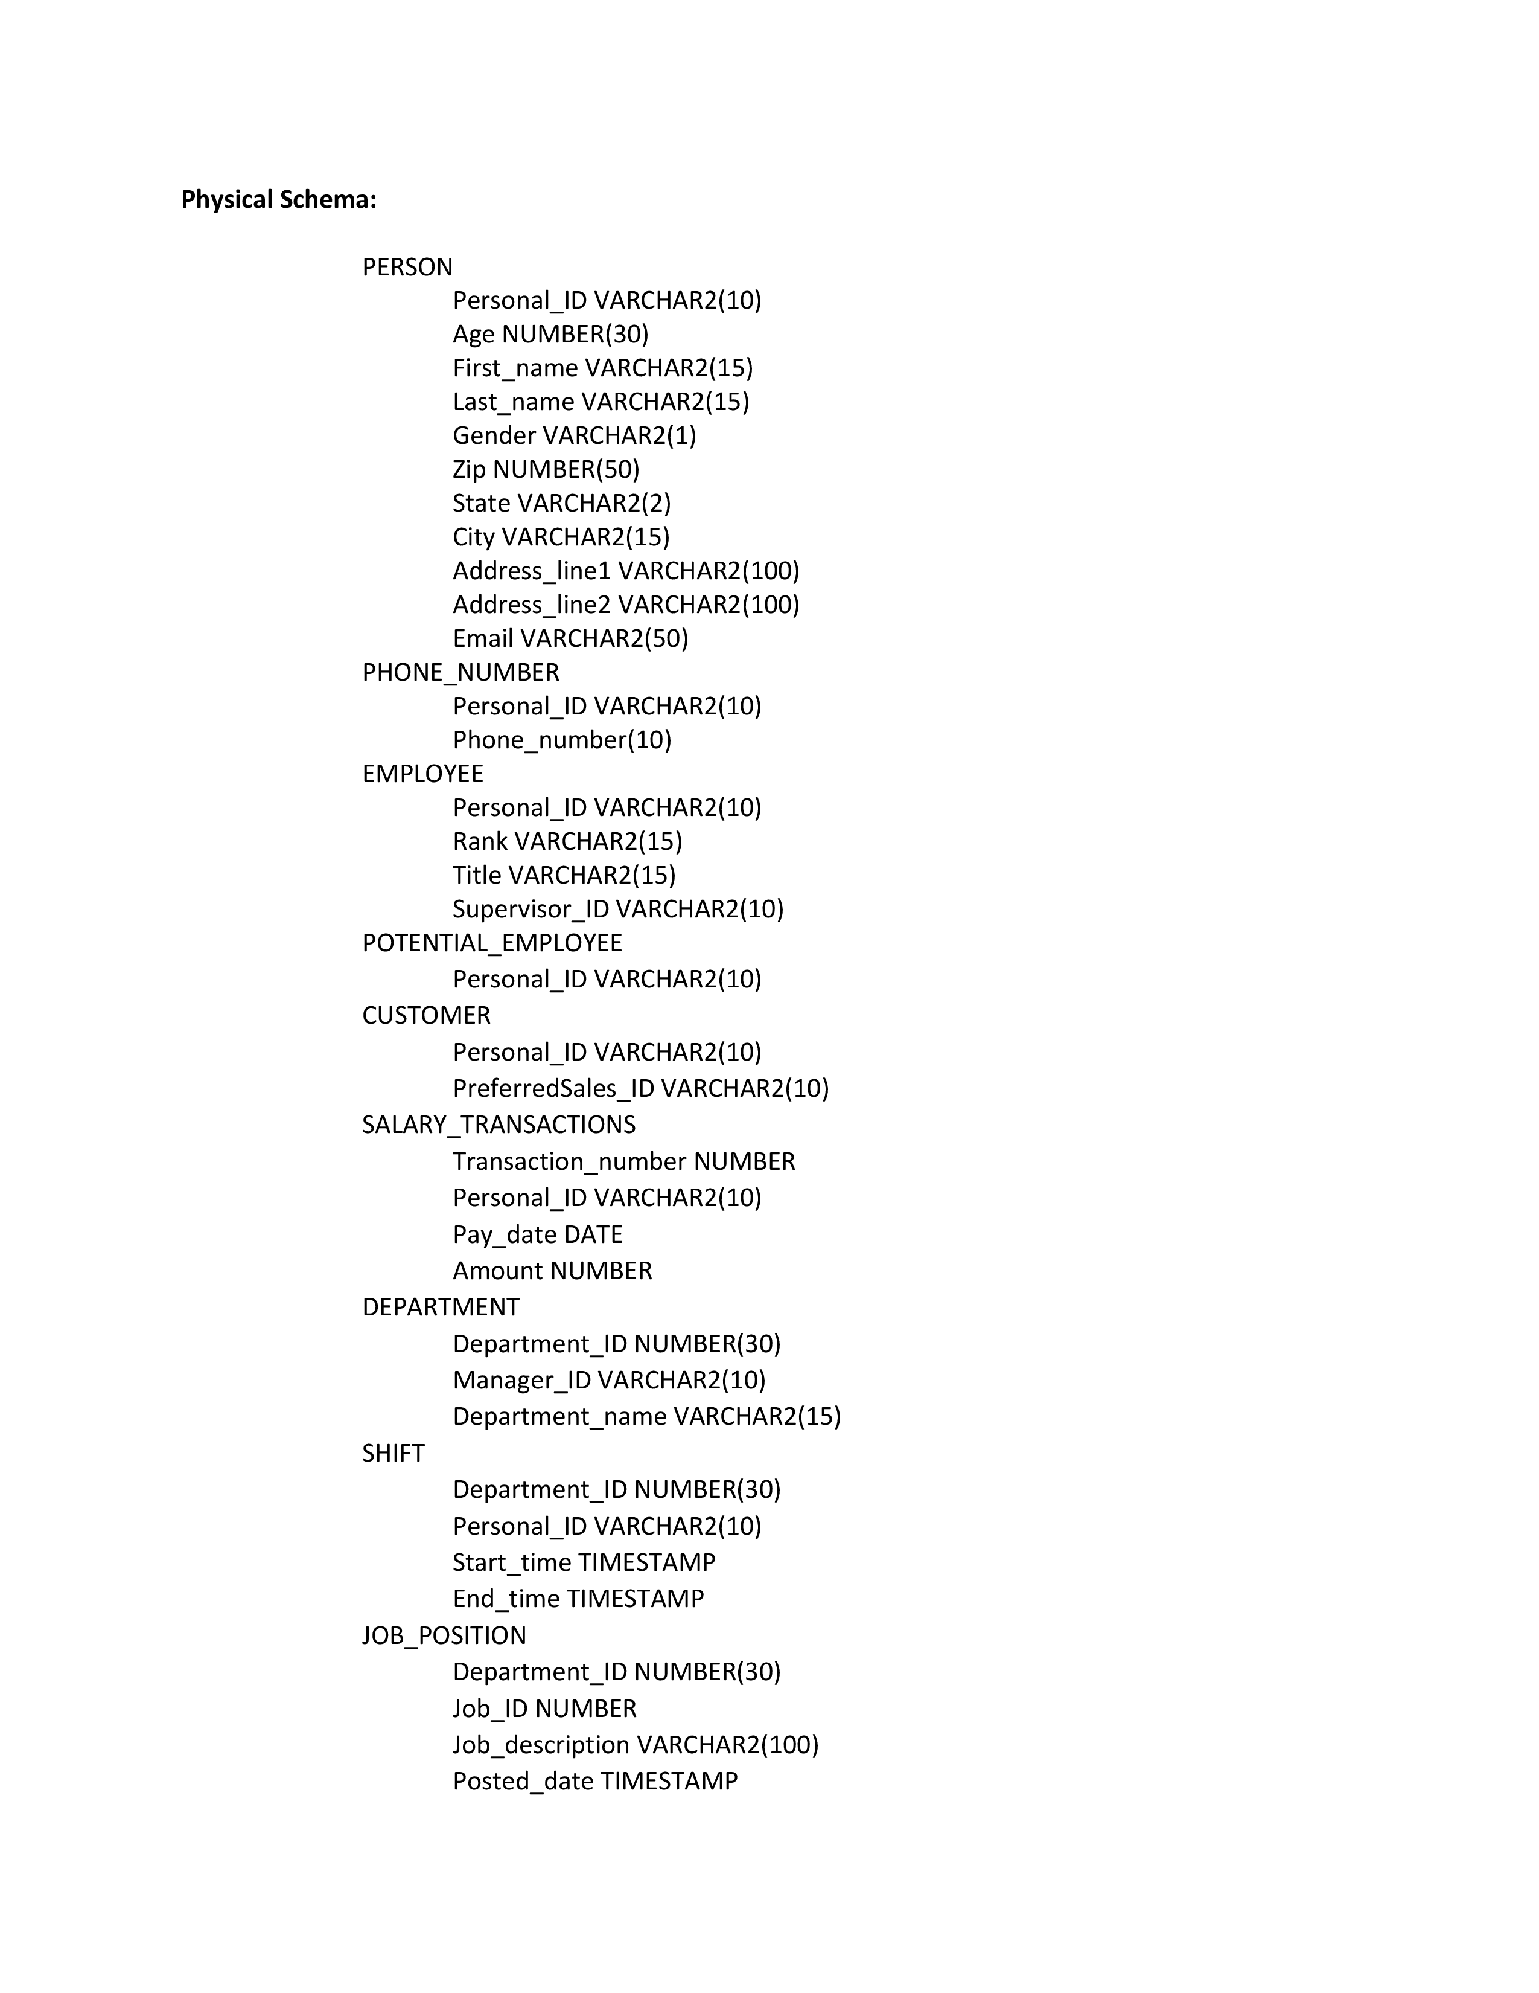

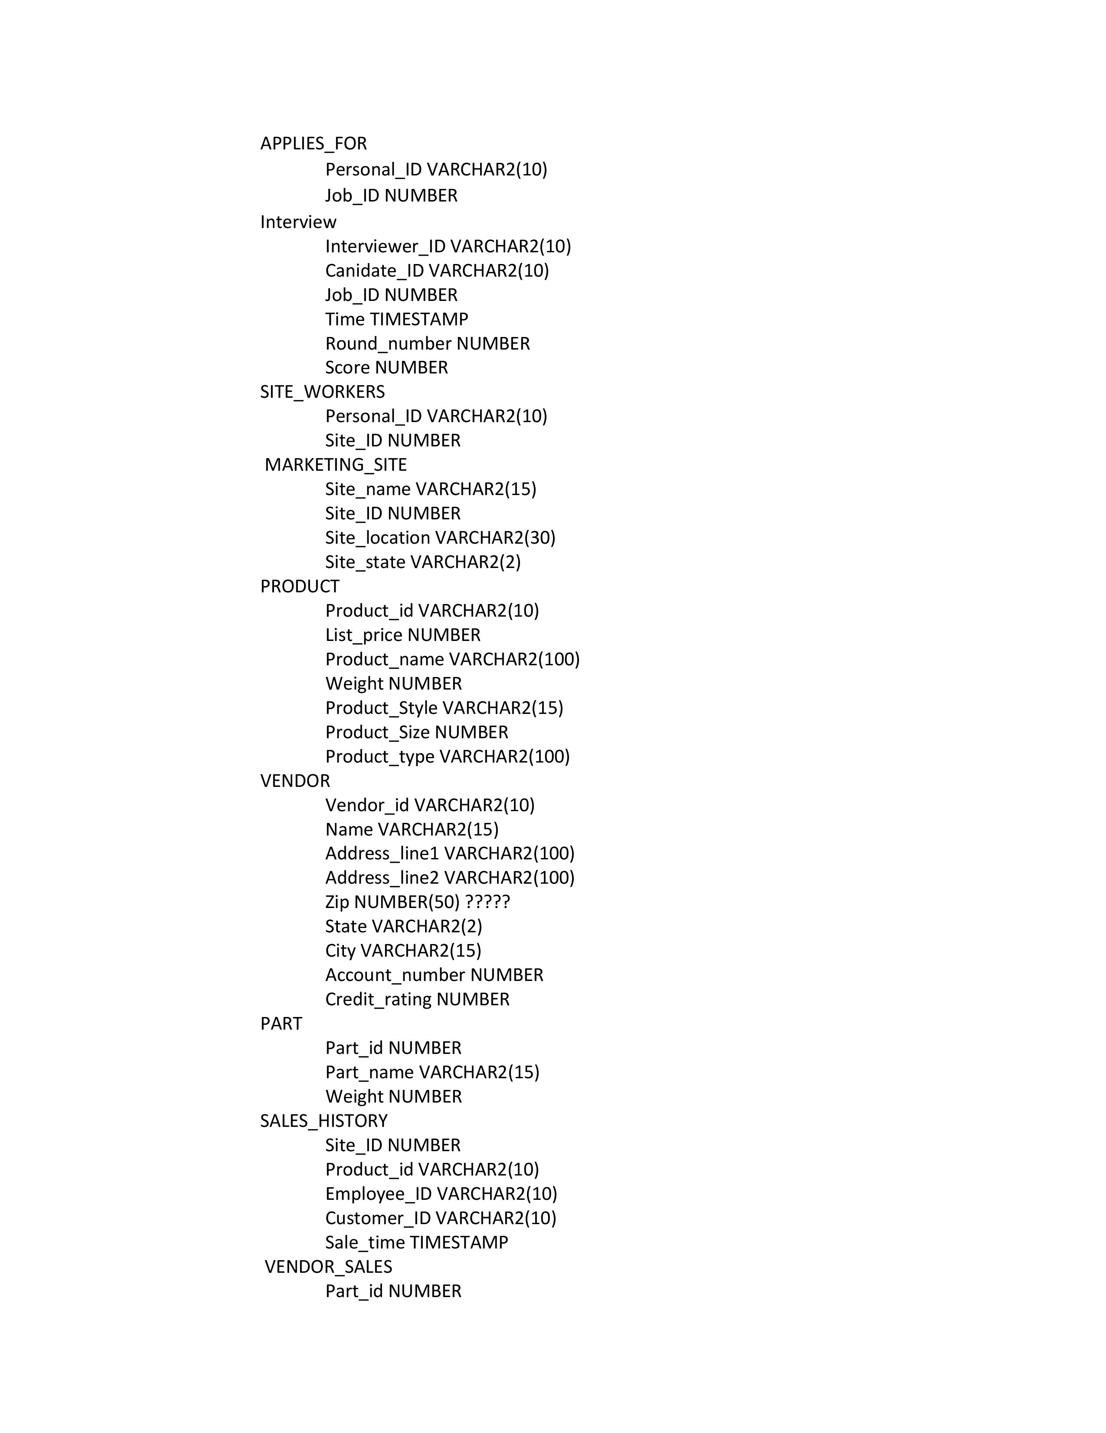



III. Use appropriate naming conventions for all of your tables and attributes. (40%)

a) Normalize all of your tables to third normal form. Make any necessary changes to the EER. Explain why these changes needed to be made.

No changes were made. All tables were already in 3NF (shown in the 3NF diagram)

b) Draw a dependency diagram for each table

**

3NF Diagram

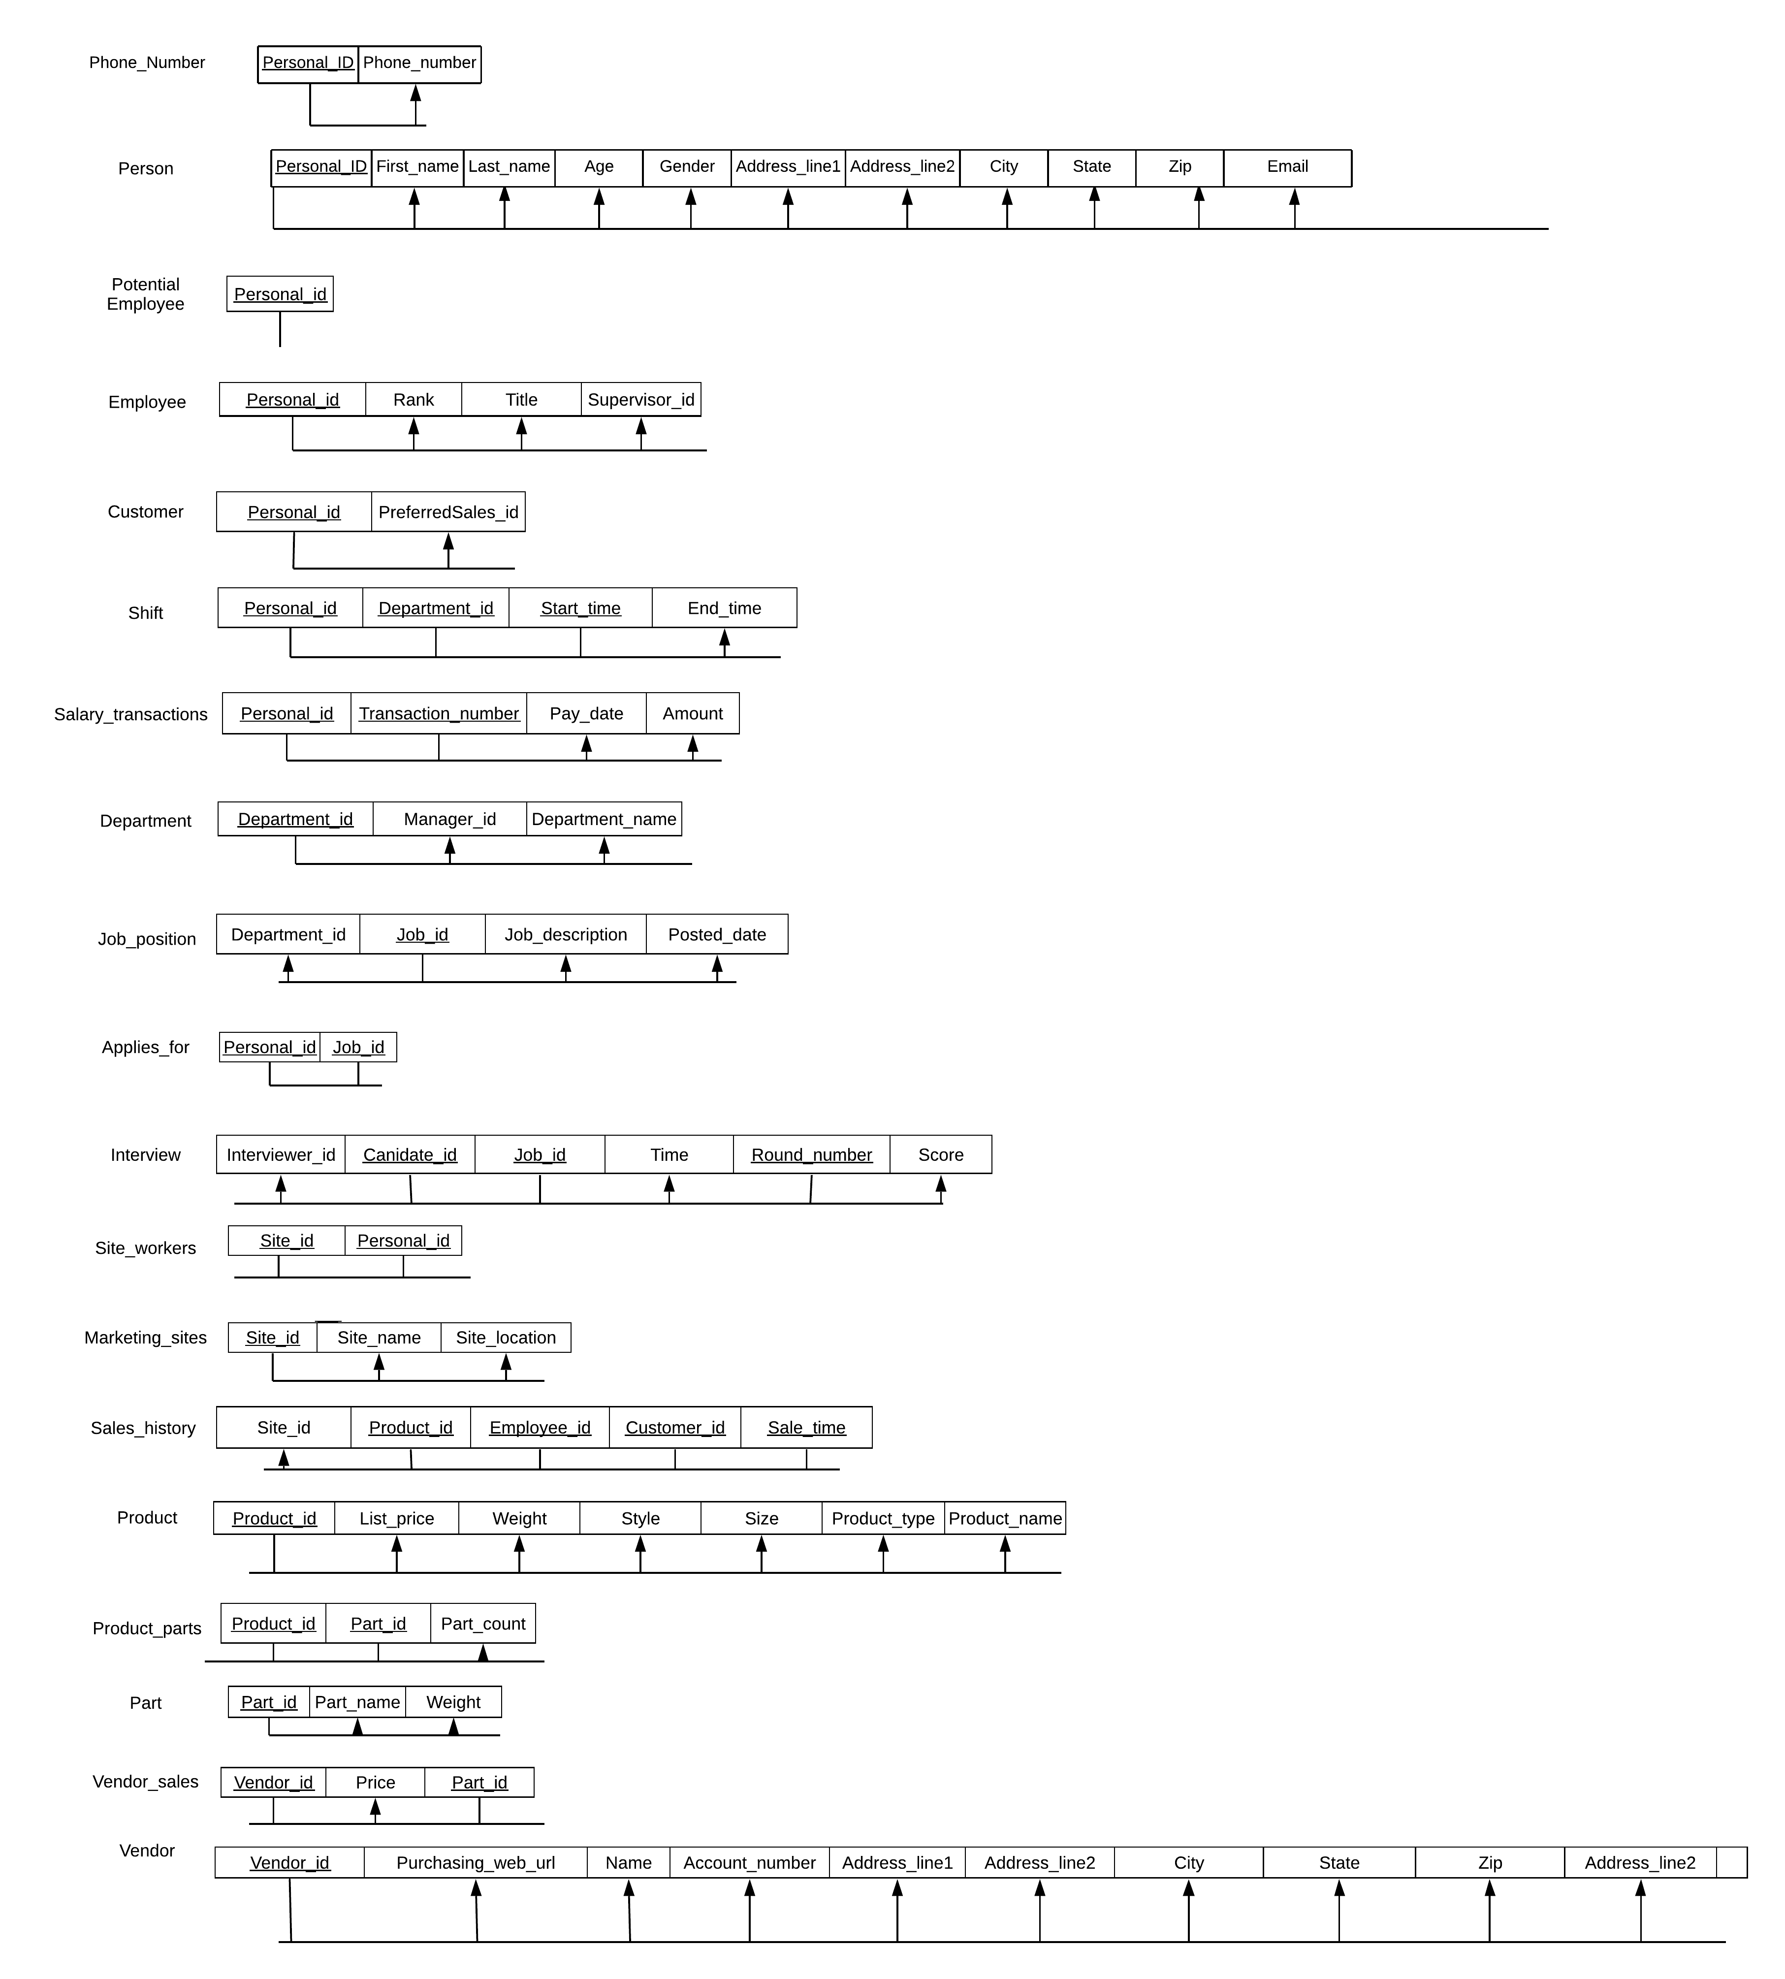

You can get all the other attributes in a tuple just by the primary key(s). There is no transitive or partial dependency, therefore all the tables are in 3NF.

c) Write SQL statements to create database, tables and all other structures. Primary keys and foreign keys must be defined appropriately. The quantity constraints of the relation between the entities, which should be described in EER diagram, are not required.

(The script is in CS 4347 - PROJ-TABLE-SCRIPT)

CREATE TABLE PART(Part_id NUMBER NOT NULL,

Part_name VARCHAR2(15) NOT NULL,

Weight NUMBER NOT NULL,

PRIMARY KEY(Part_id));

CREATE TABLE PRODUCT(Product_id VARCHAR2(10) NOT NULL,

List_price NUMBER NOT NULL,

Product_name VARCHAR2(15) NOT NULL,

Weight NUMBER NOT NULL,

Product_Style VARCHAR2(15) NOT NULL,

Product_size NUMBER NOT NULL,

Product_type VARCHAR2(100) NOT NULL,

PRIMARY KEY(Product_id));

CREATE TABLE MARKETING_SITE(Site_name VARCHAR2(15) NOT NULL,

Site_ID NUMBER NOT NULL,

Site_location VARCHAR2(30) NOT NULL,

Site_state VARCHAR2(2) NOT NULL,

PRIMARY KEY(Site_ID));

CREATE TABLE VENDOR(Vendor_id VARCHAR2(10) NOT NULL,

Name VARCHAR2(15) NOT NULL,

Address_line1 VARCHAR2(100) NOT NULL,

Address_line2 VARCHAR2(100),

Zip NUMBER(5,0) NOT NULL,

State VARCHAR2(2) NOT NULL,

City VARCHAR2(15) NOT NULL,

Account_number NUMBER NOT NULL,

Credit_rating NUMBER NOT NULL,

PURCHASING_WEB_URL VARCHAR2(100) NOT NULL,

PRIMARY KEY(Vendor_id));

CREATE TABLE VENDOR_SALES(Part_id NUMBER NOT NULL,

Price NUMBER NOT NULL,

Vendor_id VARCHAR2(10) NOT NULL,

PRIMARY KEY(Part_id,Vendor_id),

FOREIGN KEY(Part_id) REFERENCES PART(Part_id),

FOREIGN KEY(Vendor_id) REFERENCES VENDOR(Vendor_id));

CREATE TABLE PRODUCT_PARTS(Product_id VARCHAR2(10) NOT NULL,

Part_id NUMBER NOT NULL,

Part_count NUMBER NOT NULL,

PRIMARY KEY(Product_id, Part_id),

FOREIGN KEY(Part_id) REFERENCES PART(Part_id),

FOREIGN KEY(Product_id) REFERENCES PRODUCT(Product_id));

CREATE TABLE PERSON(Personal_ID VARCHAR2(10) NOT NULL,

Age NUMBER(3,0) NOT NULL,

First_name VARCHAR2(15) NOT NULL,

Last_name VARCHAR2(15) NOT NULL,

Gender VARCHAR2(1) NOT NULL,

Zip NUMBER NOT NULL,

State VARCHAR2(2) NOT NULL,

City VARCHAR2(15) NOT NULL,

Address_line1 VARCHAR2(100) NOT NULL,

Address_line2 VARCHAR2(15),

Email VARCHAR2(50) NOT NULL,

PRIMARY KEY(Personal_ID));

CREATE TABLE POTENTIAL_EMPLOYEE(Personal_ID VARCHAR2(10) NOT NULL,

PRIMARY KEY(Personal_ID),

FOREIGN KEY(Personal_ID) REFERENCES PERSON(Personal_ID));

CREATE TABLE EMPLOYEE(Personal_ID VARCHAR2(10) NOT NULL,

Rank VARCHAR2(15) NOT NULL,

Title VARCHAR2(15) NOT NULL,

Supervisor_ID VARCHAR2(10),

PRIMARY KEY(Personal_ID),

FOREIGN KEY(Personal_ID) REFERENCES PERSON(Personal_ID));

CREATE TABLE DEPARTMENT(Department_ID NUMBER(3,0) NOT NULL,

Manager_ID VARCHAR2(10) NOT NULL,

Department_name VARCHAR2(15) NOT NULL,

PRIMARY KEY(Department_ID));

alter table EMPLOYEE add FOREIGN KEY(Supervisor_ID) REFERENCES EMPLOYEE(Personal_ID);

alter table DEPARTMENT ADD FOREIGN KEY(Manager_ID) REFERENCES EMPLOYEE(Personal_ID);

CREATE TABLE CUSTOMER(Personal_ID VARCHAR2(10) NOT NULL,

PreferredSales_ID VARCHAR2(10) NOT NULL,

PRIMARY KEY(Personal_ID),

FOREIGN KEY(Personal_ID) REFERENCES PERSON(Personal_ID),

FOREIGN KEY(PreferredSales_ID) REFERENCES EMPLOYEE(Personal_ID));

CREATE TABLE SALARY_TRANSACTIONS(Transaction_number NUMBER NOT NULL,

Personal_ID VARCHAR2(10) NOT NULL,

Pay_date TIMESTAMP NOT NULL,

Amount NUMBER NOT NULL,

PRIMARY KEY(Personal_ID, Transaction_number));

CREATE TABLE SHIFT(Department_ID NUMBER(3,0) NOT NULL,

Personal_ID VARCHAR2(10) NOT NULL,

Start_time TIMESTAMP NOT NULL,

End_time TIMESTAMP NOT NULL,

PRIMARY KEY(Department_ID, Personal_ID, Start_time),

FOREIGN KEY(Personal_ID) REFERENCES EMPLOYEE(Personal_ID),

FOREIGN KEY(Department_ID) REFERENCES DEPARTMENT (Department_ID));

CREATE TABLE JOB_POSITION(Department_ID NUMBER(3,0) NOT NULL,

Job_ID NUMBER NOT NULL,

Job_description VARCHAR2(100) NOT NULL,

Posted_date TIMESTAMP NOT NULL,

PRIMARY KEY(Job_ID),

FOREIGN KEY(Department_ID) REFERENCES DEPARTMENT (Department_ID));

CREATE TABLE APPLIES_FOR(Personal_ID VARCHAR2(10) NOT NULL,

Job_ID NUMBER NOT NULL,

PRIMARY KEY(Personal_ID, Job_ID),

FOREIGN KEY(Personal_ID)REFERENCES PERSON(Personal_ID),

FOREIGN KEY(Job_ID)REFERENCES JOB_POSITION(Job_ID));

CREATE TABLE SITE_WORKERS(Personal_ID VARCHAR2(10) NOT NULL,

Site_ID NUMBER NOT NULL,

PRIMARY KEY(Site_ID, Personal_ID),

FOREIGN KEY(Personal_ID) REFERENCES EMPLOYEE(Personal_ID),

FOREIGN KEY(Site_ID) REFERENCES MARKETING_SITE(Site_ID));

CREATE TABLE Interview(Interviewer_ID VARCHAR2(10) NOT NULL,

Canidate_ID VARCHAR2(10) NOT NULL,

Job_ID NUMBER NOT NULL,

Time TIMESTAMP NOT NULL,

Round_number NUMBER NOT NULL,

Score NUMBER NOT NULL,

PRIMARY KEY(Canidate_id, Job_ID, Round_number),

FOREIGN KEY(Interviewer_ID) REFERENCES EMPLOYEE(Personal_ID),

FOREIGN KEY(Canidate_ID) REFERENCES POTENTIAL_EMPLOYEE (Personal_ID),

FOREIGN KEY(Job_ID) REFERENCES Job_position (Job_ID));

CREATE TABLE PHONE_NUMBER(

Personal_ID VARCHAR2(10) NOT NULL,

Phone_number NUMBER(10) NOT NULL,

PRIMARY KEY(Personal_ID, Phone_number),

FOREIGN KEY(Personal_ID) REFERENCES PERSON(Personal_ID));

CREATE TABLE SALES_HISTORY(Site_ID NUMBER NOT NULL,

Product_id VARCHAR2(10) NOT NULL,

Employee_ID VARCHAR2(10) NOT NULL,

Customer_ID VARCHAR2(10) NOT NULL,

Sale_time TIMESTAMP NOT NULL,

PRIMARY KEY(Site_ID ,Product_id, Employee_ID, Customer_ID, Sale_time),

FOREIGN KEY(Site_ID) REFERENCES MARKETING_SITE(Site_ID),

FOREIGN KEY(Product_id) REFERENCES PRODUCT(Product_id),

FOREIGN KEY(Employee_ID) REFERENCES EMPLOYEE(Personal_ID),

FOREIGN KEY(Customer_ID) REFERENCES CUSTOMER(Personal_ID));

--Check conditions

alter table PERSON add CHECK(Age between 16 and 65);

alter table SALARY_TRANSACTIONS add CHECK(Transaction_number between 1 and 999999);

alter table SALARY_TRANSACTIONS add CHECK(Amount between 1 and 999999999);

alter table DEPARTMENT add CHECK(Department_ID between 100 and 999);

alter table SHIFT add CHECK(Department_ID between 100 and 999);

alter table JOB_POSITION add CHECK(Job_ID between 1 and 9999999);

alter table APPLIES_FOR add CHECK(Job_ID between 1 and 9999999);

alter table Interview add CHECK(Job_ID between 1 and 9999999);

alter table Interview add CHECK(Round_number between 1 and 100);

alter table MARKETING_SITE add CHECK(Site_ID between 1 and 99999);

alter table SITE_WORKERS add CHECK(Site_ID between 1 and 99999);

alter table PRODUCT add CHECK(List_price between 1 and 99999);

alter table PRODUCT add CHECK(Weight between 1 and 99999);

alter table PRODUCT add CHECK(Product_Size between 1 and 99999);

alter table VENDOR add CHECK(Account_number between 1 and 99999);

alter table VENDOR add CHECK(Credit_rating between 1 and 99999);

alter table PART add CHECK(Part_id between 1 and 99999);

alter table PART add CHECK(Weight between 1 and 99999);

alter table SALES_HISTORY add CHECK(Site_ID between 1 and 99999);

alter table VENDOR_SALES add CHECK(Part_id between 1 and 99999);

alter table VENDOR_SALES add CHECK(Price between 1 and 99999);

alter table PRODUCT_PARTS add CHECK(Part_id between 1 and 99999);

alter table PRODUCT_PARTS add CHECK(Part_count between 1 and 99999

**d)** Use the Create View statement to create the following views:

**1) -**View1: This view returns the average salary each employee has earned from the company monthly after she/he becomes an employee in the company.

CREATE VIEW SALARY_AVERAGE AS

SELECT P.Personal_ID AS Salary_ID,P.First_name AS Salary_fname,P.Last_name AS Salary_lname,AVG(S.Amount) AS Salary_avg

FROM SALARY_TRANSACTIONS S,PERSON P

WHERE P.Personal_ID=S.Personal_ID

GROUP BY P.Personal_ID,P.First_name,P.Last_name,S.Amount

ORDER BY AVG(S.Amount) DESC;

**2) -**View2: This view returns the number of interview rounds each interviewee pass for each job position.

CREATE VIEW ROUND_PASS AS

SELECT Canidate_ID AS Round_ID,Job_ID AS Round_JOB, Count(*) AS Round_count

FROM INTERVIEW

GROUP BY Canidate_ID,Job_ID

HAVING AVG(SCORE) > 60

ORDER BY Canidate_ID,Job_ID;

**3) -**View3: This view returns the number of items of each product type sold.

CREATE VIEW PRODUCT_SOLD AS

SELECT Product_type AS Sold_type, Count_sold AS SOLD

FROM PRODUCT P, (SELECT S.Product_id AS S_ID,Count(S.Product_id) AS Count_sold

FROM SALES_HISTORY S

GROUP BY S.Product_id)

WHERE P.Product_id=S_ID

GROUP BY Product_type,Count_sold;

**4) -**View4: This view returns the part purchase cost for each product.

CREATE VIEW PRODUCT_SOLD AS

SELECT Product_type AS Sold_type,Count(*) AS Sold_count

FROM PRODUCT

WHERE Product_id IN(SELECT Product_id

FROM SALES_HISTORY)

GROUP BY Product_type;

**e)** Answer the following Queries. Feel free to use any of the views that you created in part (d).

1)- Return the ID and Name of interviewers who participate in interviews where the interviewee’s name is “Hellen Cole” arranged for job “11111”.

SELECT Personal_ID,First_name, Last_name

FROM PERSON, Interview

WHERE Interviewer_ID=Personal_ID and Job_ID=11111 AND Canidate_ID IN( SELECT Personal_id

FROM PERSON

WHERE First_name='Hellen' AND Last_name='Cole');

2) -Return the ID of all jobs which are posted by department “Marketing” in January, 2011.  
  
 SELECT J.Job_ID

FROM JOB_POSITION J, DEPARTMENT D

WHERE J.Posted_date BETWEEN TO_DATE('2011-01-01','YYYY-MM-DD') AND TO_DATE('2011-1-31','YYYY-MM-DD') AND J.Department_ID=D.Department_ID

AND D.Department_name='Marketing';

3) -Return the ID and Name of the employees having no any superviesees.

SELECT P.Personal_ID,P.First_name,P.Last_name

FROM Person P

WHERE Personal_ID IN(

SELECT E.Personal_ID

FROM EMPLOYEE E

WHERE E.Personal_id NOT IN(SELECT Supervisor_ID

FROM EMPLOYEE

WHERE Supervisor_ID IS NOT NULL));

4) -Return the Id and Location of the marketing sites which have no any sale records during March, 2011.  
  
 SELECT Distinct Site_ID,Site_location,Site_state

FROM MARKETING_SITE

WHERE Site_ID NOT IN(SELECT Site_ID

FROM SALES_HISTORY

WHERE Sale_time BETWEEN TO_DATE('2011-03-01','YYYY-MM-DD') AND TO_DATE('2011-03-31','YYYY-MM-DD'));

Assumption: Between is an inclusive range, so it will include '2011-03-01'and '2011-03-31'

5) -Return the job’s id and description which does not hire a suitable person one month after it is posted.

SELECT Job_ID,Job_description

FROM JOB_POSITION

WHERE Job_ID NOT IN(

SELECT I.Job_ID

FROM JOB_POSITION J, Interview I

WHERE J.Job_ID=I.Job_ID AND I.Time BETWEEN TO_TIMESTAMP(TO_CHAR(J.Posted_date, 'YYYYMMDD HH24:MI'),

'YYYYMMDD HH24:MI') AND TO_TIMESTAMP(TO_CHAR(ADD_MONTHS(J.Posted_date, 1), 'YYYYMMDD HH24:MI'),

'YYYYMMDD HH24:MI')

GROUP BY I.Canidate_ID,I.Job_ID

HAVING COUNT(*) >= 5 AND AVG(Score) > 70);

6) -Return the ID and Name of the salesmen who have sold all product type whose price is above $200.

SELECT Personal_ID, First_name,Last_name

FROM PERSON

WHERE Personal_ID IN(SELECT Personal_ID

FROM EMPLOYEE, (SELECT S.Employee_ID AS Seller_ID, COUNT(DISTINCT S.Product_ID) AS Seller_count, COUNT(DISTINCT P.Product_ID)AS Price_count

FROM SALES_HISTORY S,Product P

WHERE P.List_price>200 AND S.Product_ID IN(SELECT R.Product_ID

FROM Product R

WHERE List_price>200)

GROUP BY S.Employee_ID)

WHERE Seller_count=Price_count AND Personal_ID=Seller_ID);

7) -Return the department’s id and name which has no job post during 1/1/2011 and 2/1/2011.

SELECT Department_id,Department_name

FROM DEPARTMENT

WHERE Department_id NOT IN(SELECT DISTINCT Department_id

FROM JOB_POSITION

WHERE Posted_date BETWEEN TO_DATE('2011-01-01','YYYY-MM-DD') AND TO_DATE('2011-02-01','YYYY-MM-DD'));

Assumption: Between is an inclusive range, so it will include 1/1/2011 and 2/1/2011

8) -Return the ID, Name, and Department ID of the existing employees who apply job “12345”.

SELECT Personal_ID,First_name,Last_name,Department_ID

FROM PERSON,Job_position

WHERE Job_ID=12345 AND Personal_ID IN(SELECT Personal_ID

FROM EMPLOYEE

WHERE Personal_ID IN(SELECT Personal_ID

FROM APPLIES_FOR

WHERE Job_ID=12345));

9) -Return the best seller’s type in the company (sold the most items).

SELECT DISTINCT Product_type

FROM PRODUCT

WHERE Product_ID IN(SELECT Product_id

FROM SALES_HISTORY

GROUP BY Product_id

ORDER BY count(*) DESC

FETCH FIRST ROW ONLY);

10) Return the product type whose net profit is highest in the company (money earned minus the part cost).

SELECT P.Product_type, SUM(P.List_price-Sum_costs)

FROM PRODUCT_4,PRODUCT P,SALES_HISTORY S

WHERE P.Product_ID=Product_ID_PARTS AND P.Product_ID IN

(SELECT Product_id

FROM SALES_HISTORY)

GROUP BY P.Product_type

ORDER BY SUM(P.List_price-Sum_costs) DESC

FETCH FIRST ROW ONLY;

11) -Return the name and id of the employees who has worked in all departments after hired by the company.  
  
 SELECT Personal_ID,First_name,Last_name

FROM PERSON, (SELECT DISTINCT Personal_ID AS E_ID, Count(DISTINCT S.Department_ID)AS E_count

FROM SHIFT S

GROUP BY Personal_ID

HAVING COUNT(DISTINCT S.Department_ID) = (SELECT COUNT(*)

FROM DEPARTMENT))

WHERE Personal_ID=E_ID;

12) -Return the name and email address of the interviewee who is selected.

SELECT DISTINCT P.First_name, P.Last_name, P.Email

FROM PERSON P

WHERE P.Personal_ID IN(

SELECT Canidate_ID

FROM INTERVIEW

GROUP BY Canidate_ID,Job_ID

HAVING COUNT(*) >= 5 AND AVG(SCORE) > 70);

13) -Retrieve the name, phone number, email address of the interviewees selected for all the jobs they apply.

SELECT P.Personal_ID,P.First_name,P.Last_name,R.Phone_number,P.Email

FROM PERSON P,PHONE_NUMBER R

WHERE P.Personal_ID IN(SELECT A.Personal_ID

FROM APPLIES_FOR A

WHERE A.Personal_ID NOT IN(

SELECT DISTINCT Canidate_ID

FROM INTERVIEW

GROUP BY Canidate_ID,Job_ID

HAVING AVG(Score) <= 70 OR COUNT(*) < 5

UNION

SELECT DISTINCT Personal_ID

FROM APPLIES_FOR

WHERE Personal_ID NOT IN(SELECT Canidate_ID

FROM INTERVIEW)))

AND P.Personal_ID=R.Personal_ID;

14) -Return the employee’s name and id whose average monthly salary is highest in the company.

SELECT Personal_ID,First_name,Last_name

FROM PERSON

WHERE Personal_ID IN(SELECT Personal_ID

FROM SALARY_TRANSACTIONS

GROUP BY Personal_ID

ORDER BY AVG(Amount) DESC

FETCH FIRST ROW ONLY);

15) -Return the ID and Name of the vendor who supply part whose name is “Cup” and weight is smaller than 4 pound and the price is lowest among all vendors.

SELECT R.Vendor_ID,R.Name

FROM VENDOR R

WHERE R.Vendor_ID IN(SELECT V.Vendor_ID

FROM VENDOR_SALES V

WHERE V.Part_ID IN(SELECT P.Part_ID

FROM PART P

WHERE P.Weight < 4 AND P.Part_name='Cup')

ORDER BY Price DESC

FETCH FIRST ROW ONLY);

**IV.** Document the final term project report. (15%)

1. Problem description

**b)** Project questions (Answer questions listed in this project).

**c)** EER diagram with all assumptions.

**d)** Relation schema after normalization. All relations must be in 3NF. The relation schema should include primary keys as well as foreign keys (if any) for all relations.

**e)** All requested SQL statements.

**f)** Dependency diagram.

Documentation above.